Eg: String_Eg76

When you try to print object reference ,internally .toString() is called on it to print the reference . but manually we had written toString() which returns null value . so it is added to “text” variable .

Eg: String_Eg77

// go through the code , it is based on above program String_Eg76 .

Eg: String_Eg78

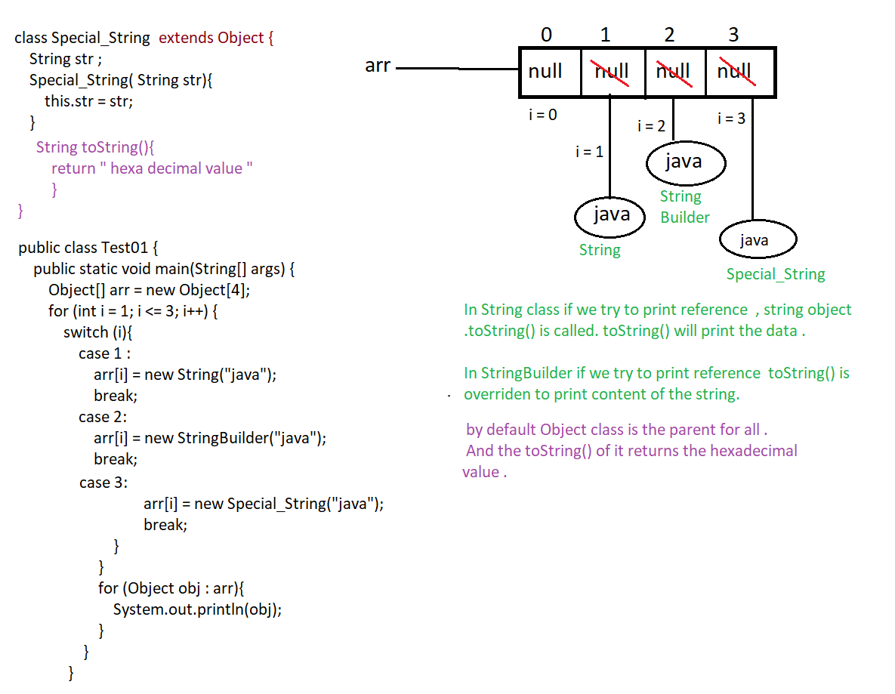

Eg: String_Eg79

// go through the command .

Eg: String_Eg80

// go through the code.

Eg: String_Eg81

// go through the code.

Eg: String_Eg82

// go through the code.

Eg: String_Eg83

// go through the code.

Eg: String_Eg84

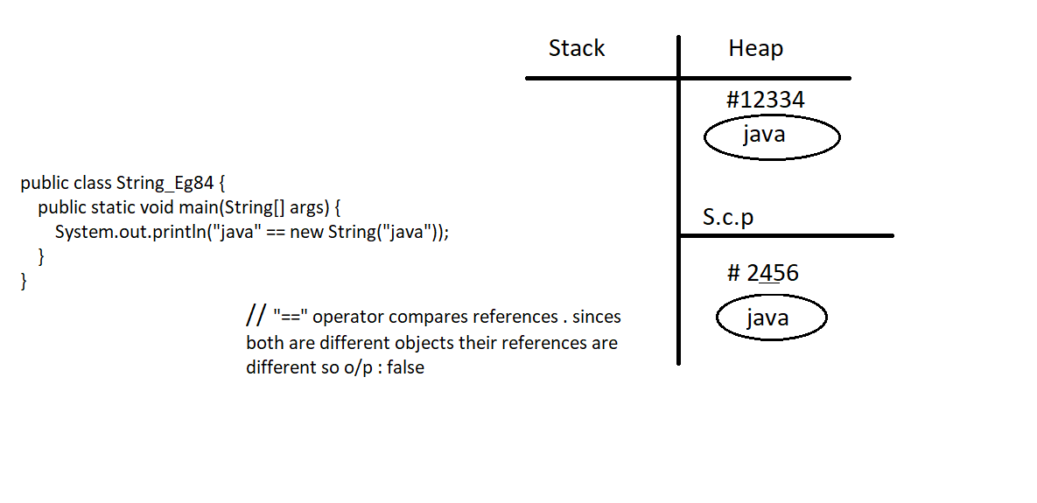

Eg: String_Eg85

// go through the code

Eg: String_Eg86

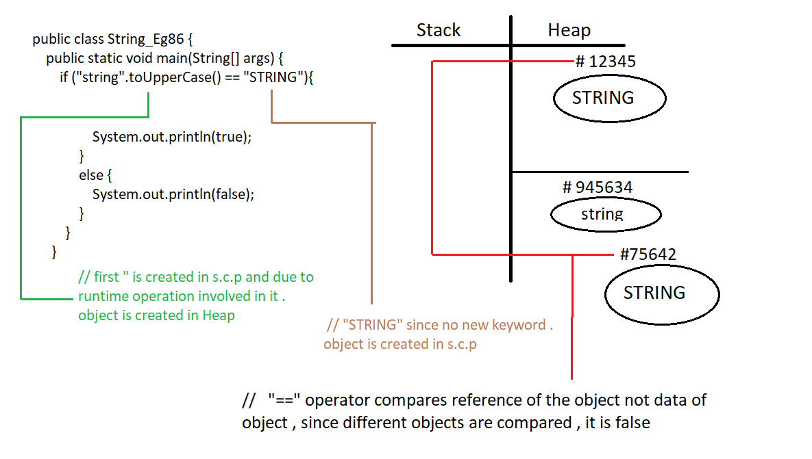

Note : String , StringBuilder , StringBuffer all these classes are final by default.

Eg:String_Eg87

// go through the code.

Note: When the string concatenation is very frequent and code is need not be thread safe , we can opt for StringBuider(1.5v)

Eg: String_Eg88

//go through the code.

Eg: String_Eg89

// go through the code

Eg: String_Eg90

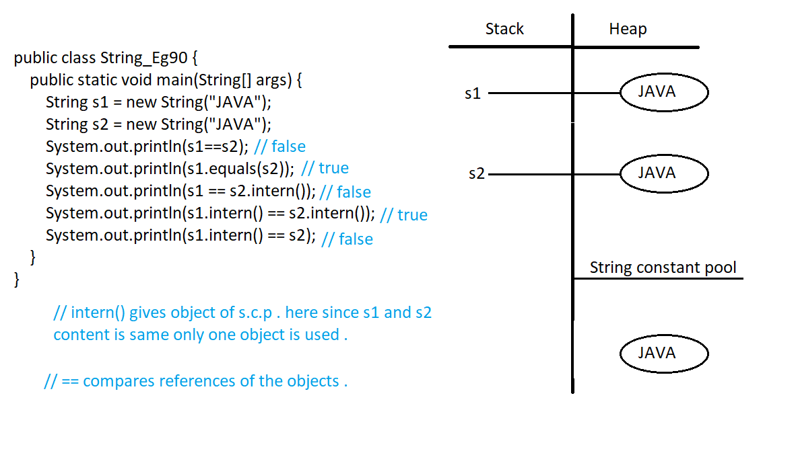

Eg: String_Eg91

// go through the code .

Note : StringBuilder( ) constructor different types of parameters , check it in the IDE.

Eg: String_Eg92

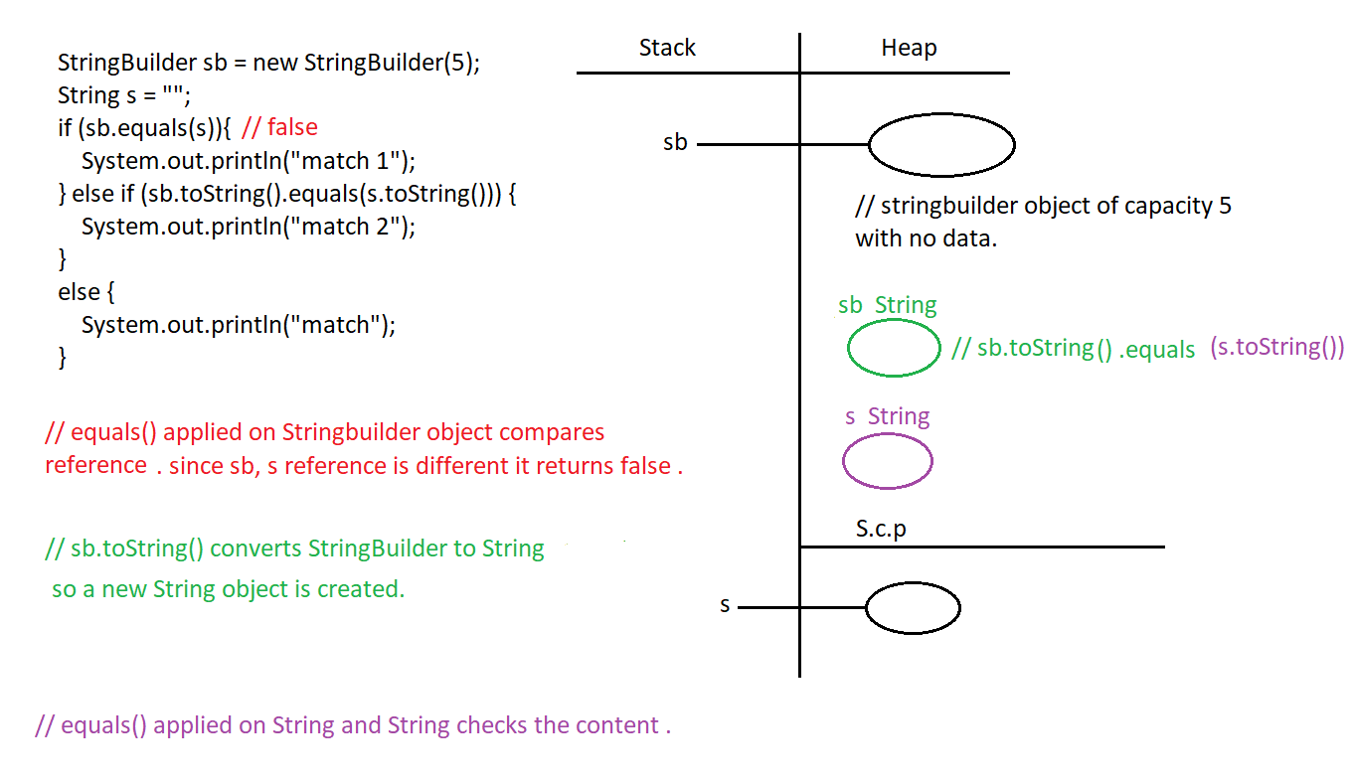

Eg: String_Eg93

// go through the code.

Eg: String_Eg94

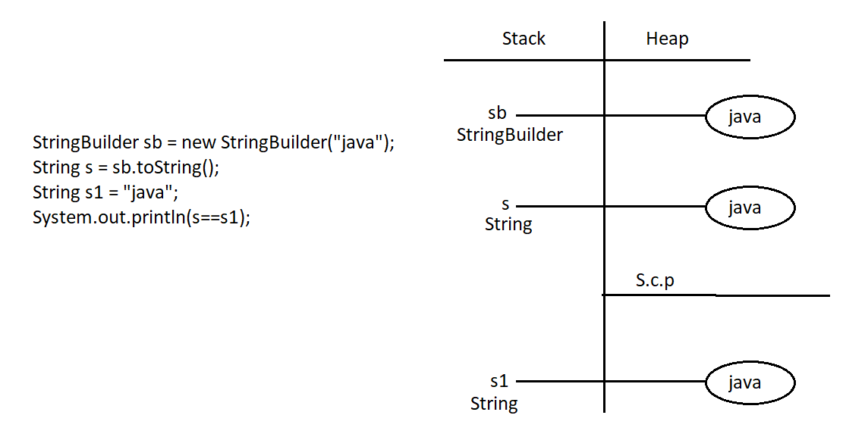

Eg: String_Eg95

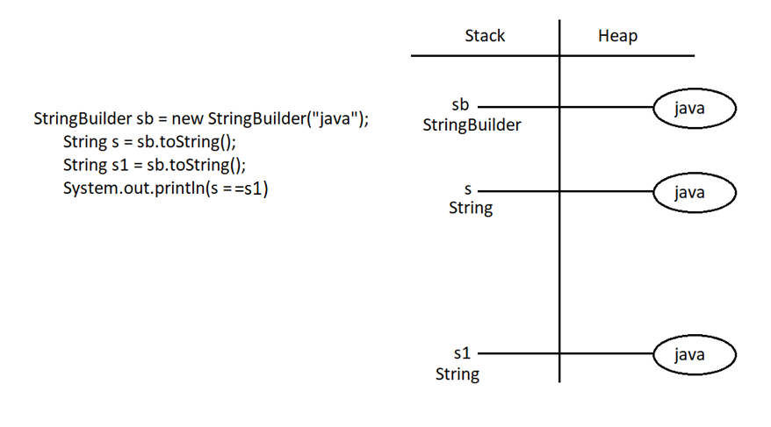

Eg:String_Eg96

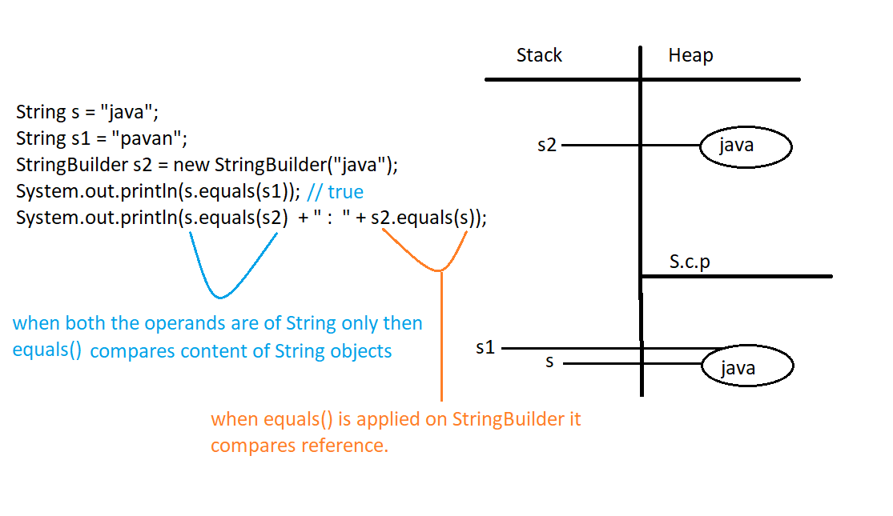

Eg:String_Eg97

// go through the code.

Eg: String_Eg98

// go through the code

Eg:String_Eg99

// go through the code

Eg: String_Eg100

// go through the code

Eg: String_Eg101

// go through the code.